**NORMAL REGRESSION MODEL**

**The final weights for model is:**

**[ 1.82272747e-03]**

**[ 2.68771513e-02]**

**[ 6.31181273e-01]**

**[-5.19294682e-01]**

**[-6.03273501e-01]**

**[ 5.10527595e-01]**

**[ 1.16188805e-01]**

**[ 1.12550172e-01]**

**[ 1.55453166e-01]**

**[-2.83770593e-02]**

**[ 3.77086579e-02]**

**[ 4.25522578e-01]**

**[ 1.04522613e-01]**

**[-2.65742242e-02]**

**[-1.28491286e-01]**

**[ 1.79904424e-01]**

**[-2.77146052e-01]**

**[-3.82771018e-01]**

**[-5.08457962e-02]**

**[-3.57583028e-01]**

**[ 1.27750531e-04]**

**[-7.19669236e-02]**

**[ 4.20908392e-02]**

**[ 2.16350276e-02]**

**[ 6.74893839e-02]**

**[-1.43804827e-02]**

**[ 0.00000000e+00]**

**Training Error is equal to: 0.446739**

**Testing Error is equal to: 0.360713**

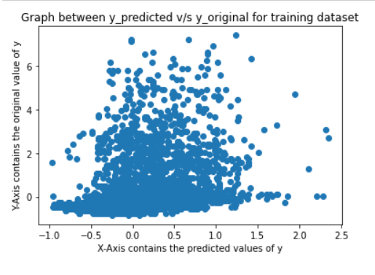

**In the graph of predicted value of y vs original value of y for training dataset, the graph is more dense in the lower region.**

**Remember the y-axis contains the original value of y and the x-axis contains the predicted values of y.**

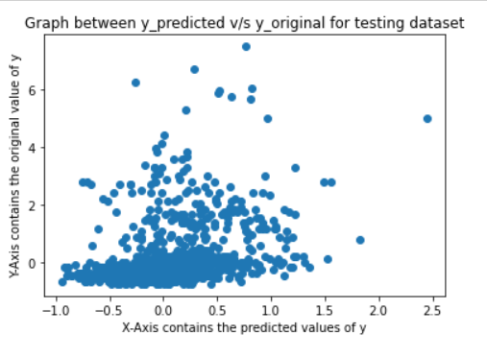

**In the graph of predicted value of y vs original value of y for testing dataset, the graph is more dense in the lower region.**

**Remember the y-axis contains the original value of y and the x-axis contains the predicted values of y.**